Kamran Gul | CMS: 023-25-0161 | CS AI (C) | Lab # 5

Task 1:
Write a program to ask user input START/END and iterate loop from start to end and perform following tasks:
a) Print numbers using FOR/WHILE/DO WHILE.
b) Test on following values and observe output (You may be asked anytime during lab regarding this observation)
c) While testing on last two inputs, it may work abnormally. Now modify above program so that it should work t time where t is difference between start/end.
d) How for/while/do-while loop behaves?
Solution:
#include<iostream>
using namespace std;
int main(){

int startValue,endValue;
int i,k=1;
cout<<"Enter Start Value: ";
cin>>startValue;
cout<<"Enter End Value: ";
cin>>endValue;
int j = endValue - startValue;
if(j>0)
cout<<"The difference between numbers is "<< j<<", Therefore, your program will run "<<j<<" times"<<endl<<endl;
while(k<=j){
for(i = startValue; i<endValue; i++){
cout<<i<<" ";
}
cout<<endl;
k++;
}
cout<<endl;
system("PAUSE");
return 0;}

Output:
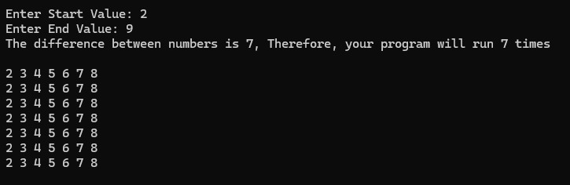

Task 2:
Write a program to ask user input n_courses (Total Courses), then iterate loop n_courses time and ask user marks in each course and perform following tasks:
a) Calculate average of all courses marks.
b) Calculate total percentage of all courses.
c) Tell the user whether s/he is PASS/FAIL, FAIL ◊ less than 60, and otherwise PASS.
Solution:
#include<iostream>
using namespace std;
int main(){
int i=1,nCourse,num=1;
float average,percentage,marks,totalMarks=0;
cout<<"Enter number of courses you have done... ";
cin>>nCourse;
while(i<=nCourse){
cout<<"Enter Marks of course "<<num<<" : ";
cin>>marks;
totalMarks+=marks;
num++;
i++;
}
cout<<endl;
average = totalMarks/nCourse;
cout<<"Your Average score is :"<<average<<endl;
percentage= (totalMarks/(nCourse*50))*100;
cout<<"Your Percentage is :"<<percentage<<endl;

if(percentage >=60)
cout<<"Congrats! You have passed the exam...";
else
cout<<"Bad Luck! You are fail...";

cout<<endl;cout<<endl;
system("PAUSE");
return 0;
}
Output:
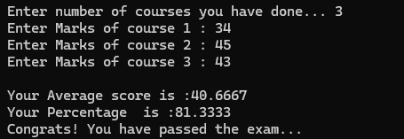

Task 3:
Write a program to output the N terms of HARMONIC series and their SUM.
Input:5
Output: 1/1 + 1/2 + 1/3 + 1/4 + 1/5
Total Sum is: 2.28333
Solution:
#include<iostream>
using namespace std;
int main(){
int i=1,nTerms;
float sum=0,totalSum=0;
cout<<"Enter number of terms: ";
cin>>nTerms;

while(i<=nTerms){
cout<<"1/"<<i<<" ";
sum = 1.0/i;
totalSum += sum;
i++;
if(i<=nTerms)
cout<<"+ ";
}
cout<<endl;
cout<<"The sum of terms is: "<<totalSum;

cout<<endl;
system("PAUSE");
return 0;
}

Output:
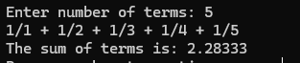

Task 4:
Write a program to ask user NAME and print “Welcome Dear NAME”, then ask user whether user wants to continue or exit (y ◊ continue, e ◊ exit). Print appropriate message to tell user how to EXIT/CONTINUE.
Note: In following each task, you have to ask user whether CONTINUE/EXIT, if continue then program should RUN AGAIN otherwise TERMINATE.
Solution:
#include<iostream>
#include<string>
using namespace std;
int main(){
string name;
char decision;
while(true){
cout<<"Enter your name: ";
cin>>name;
cout<<"Welcome dear "<<name<<endl;
cout<<"Do you want to continue (y/n): ";
cin>>decision;
if (decision=='n')
break;
}

cout<<endl;
system("PAUSE");
return 0;
}
Output:
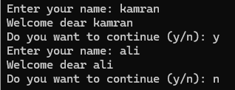

Task 5:
Write a program to ask user input N and perform following tasks: a) Check whether N is PRIME/NOT?
Solution:
#include <iostream>
#include <cmath>
using namespace std;

int main() {
int num,i,count=0;
cout << endl;
cout << "Enter number: ";
cin >> num;

if (num <= 1) {
cout << "Not Prime number";
}
else {

for (i = 2; i <= sqrt(num); i++) {
if (num % i == 0) {
cout << "Not Prime number";
break;
}
}

if (i > sqrt(num)) {
cout << "Prime number";
}
}

cout << endl;
system("PAUSE");
return 0;
}
Output:
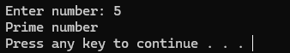

Task 6:
Write a program to ask user input N and perform following tasks:
a) Check whether N comes in FIBONACCI series or NOT?
b) Generate FIBONACCI series till N.
Note: FIBONACCI series: 0, 1, 1, 2, 3, 5, 8, 13, 21, 34, 55…
Solution:
#include <iostream>
using namespace std;

int main() {
int n;
bool found= false;
cout << "Enter number: ";
cin >> n;

int fib[n+5];

fib[0] = 0;
fib[1] = 1;

for (int i = 2; i < (n+5); i++) {
fib[i] = fib[i - 1] + fib[i - 2];
}
for (int i = 0; i < (n+5); i++) {
if(fib[i]==n){
found = true;
}}
if(found==true)
cout<<"This number is INCLUDED in fibancci series";
else
cout<<"This number is NOT INCLUDED in fibancci series";

cout<<endl;
system("PAUSE");
return 0;
}
Output:
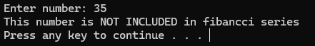
Task 7:
Write a program to ask user input N and design following patters: Input N = 5
Output:
1
1 2
1 2 3
1 2 3 4
1 2 3 4 5
Solution:
#include<iostream>
using namespace std;
int main(){
int num;
cout<<"Enter number: ";
cin>>num;

for( int i = 1; i<=num; i++){
for (int j = 1; j <= i; j++) {
cout << j << " ";
}
cout<<endl;
}
int i=0;
while(i<=num){
for (int j =65; j<65+i;j++){
cout<<(char)j << " ";
}
i++;
cout<<endl; }
cout<<endl;
system("PAUSE");
return 0;}

Output:
